AIM: Implementing the Factory Method Pattern
Scenario:
You are developing a document management system that needs to create different types of documents (e.g., Word, PDF, Excel). Use the Factory Method Pattern to achieve this.
Steps:
- Create a New Java Project:
  - Create a new Java project named FactoryMethodPatternExample.
- Define Document Classes:
  - Create interfaces or abstract classes for different document types such as WordDocument, PdfDocument, and ExcelDocument.
- Create Concrete Document Classes:
  - Implement concrete classes for each document type that implements or extends the above interfaces or abstract classes.
- Implement the Factory Method:
  - Create an abstract class DocumentFactory with a method createDocument().
  - Create concrete factory classes for each document type that extends DocumentFactory and implements the createDocument() method.
- Test the Factory Method Implementation:
  - Create a test class to demonstrate the creation of different document types using the factory method.

1. Document.java
public interface Document {
void open();
}
2. WordDocument.java
public class WordDocument implements Document {
@Override
public void open() {
System.out.println("Opening Word Document...");
}
}
3. PdfDocument.java
public class PdfDocument implements Document {
@Override
public void open() {
System.out.println("Opening PDF Document...");
}
}
4. ExcelDocument.java
public class ExcelDocument implements Document {
@Override
public void open() {
System.out.println("Opening Excel Document...");
}
}
5. DocumentFactory.java
public abstract class DocumentFactory {
public abstract Document createDocument();
}
6. WordDocumentFactory.java
public class WordDocumentFactory extends DocumentFactory {
@Override
public Document createDocument() {
return new WordDocument();
}
}
7. PdfDocumentFactory.java
public class PdfDocumentFactory extends DocumentFactory {
@Override
public Document createDocument() {
return new PdfDocument();
}
}
8. ExcelDocumentFactory.java
public class ExcelDocumentFactory extends DocumentFactory {
@Override
public Document createDocument() {
return new ExcelDocument();
}
}
9. FactoryMethodPatternExample.java
public class FactoryMethodPatternExample {
public static void main(String[] args) {
DocumentFactory wordFactory = new WordDocumentFactory();
Document wordDoc = wordFactory.createDocument();
wordDoc.open();
DocumentFactory pdfFactory = new PdfDocumentFactory();
Document pdfDoc = pdfFactory.createDocument();
pdfDoc.open();
DocumentFactory excelFactory = new ExcelDocumentFactory();
Document excelDoc = excelFactory.createDocument();
excelDoc.open();
}
}
10. Output
Opening Word Document...
Opening PDF Document...
Opening Excel Document...

SCREENSHOTS
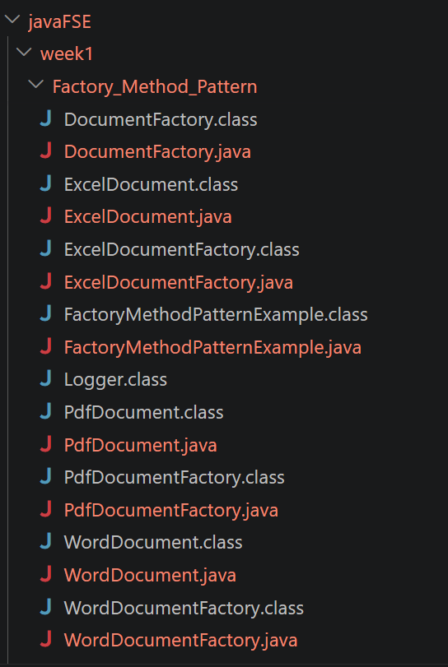
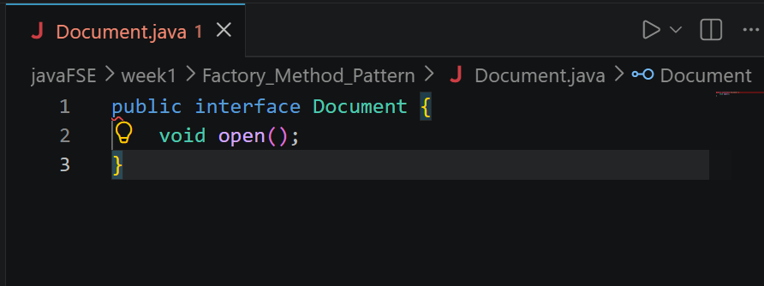
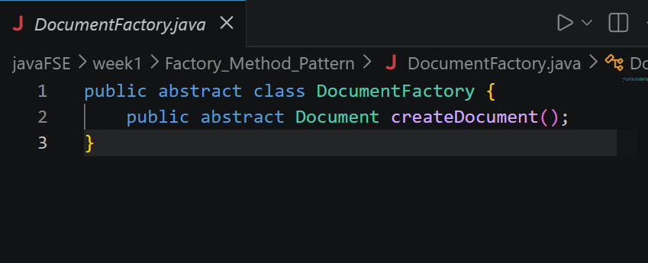
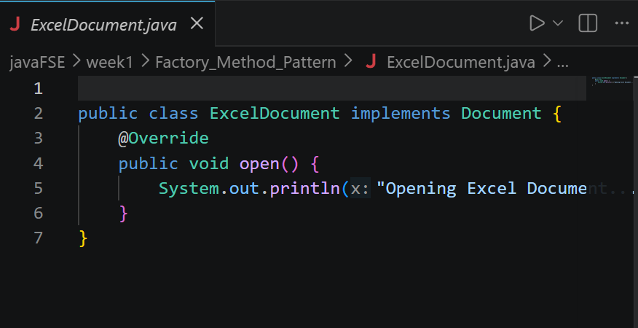
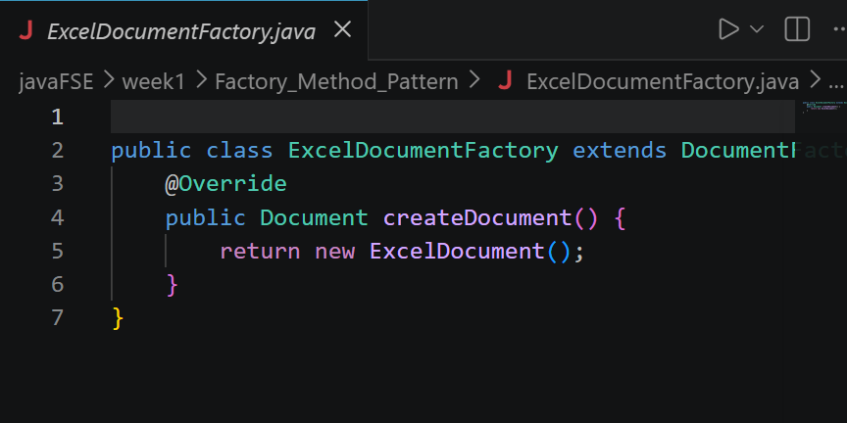
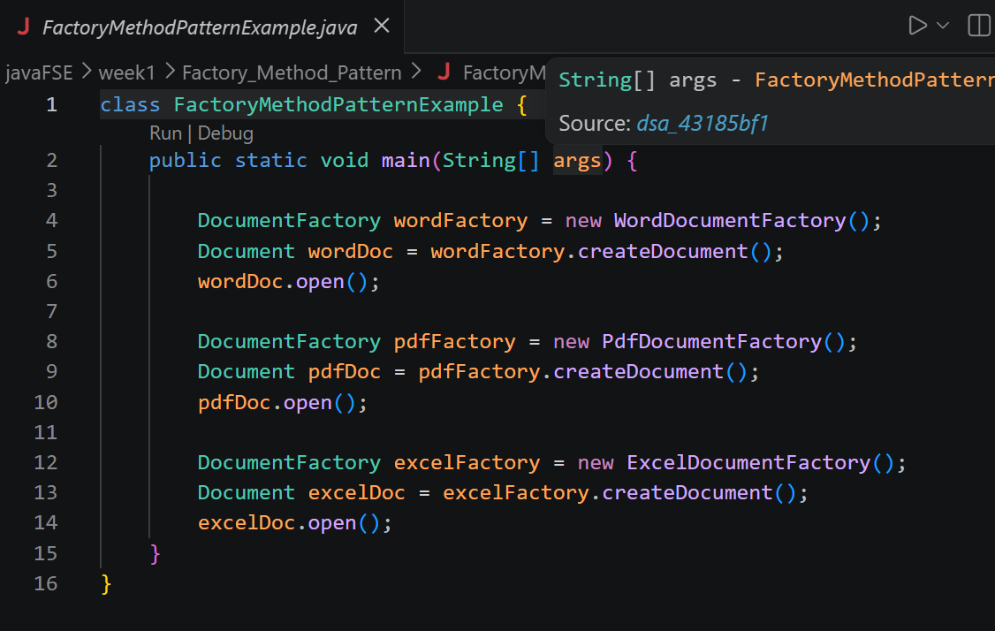
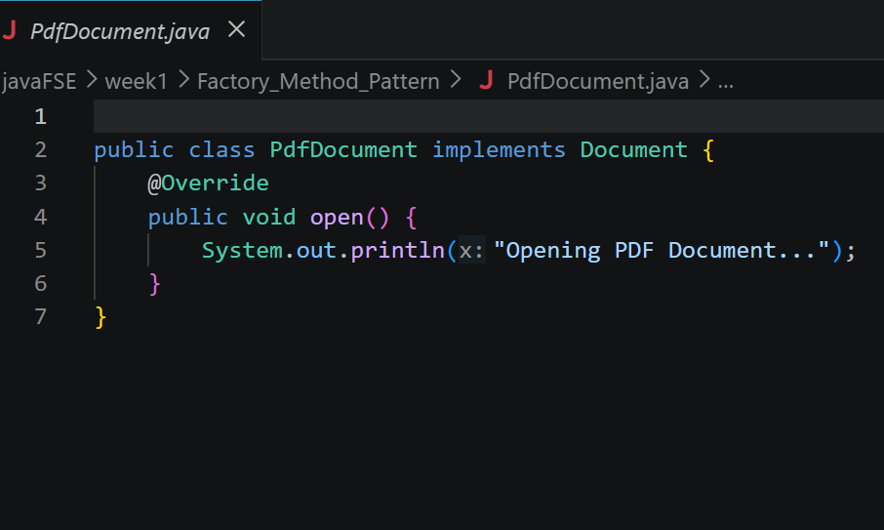
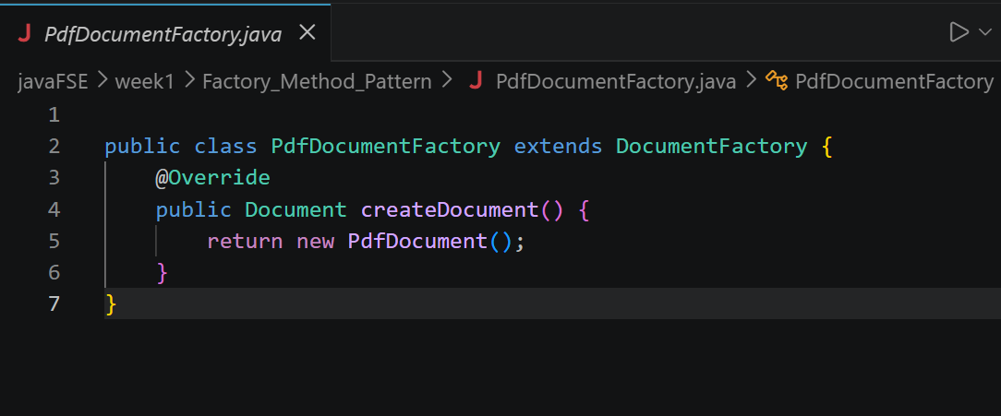
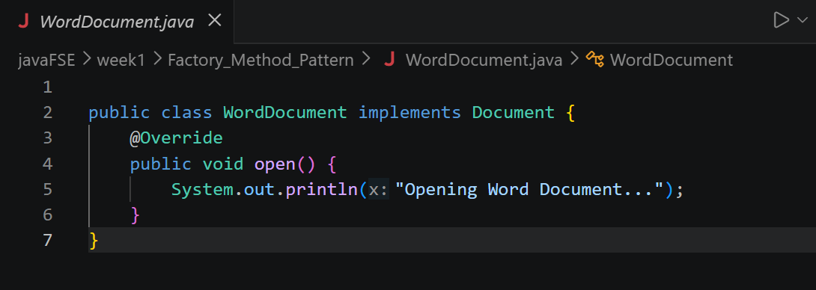
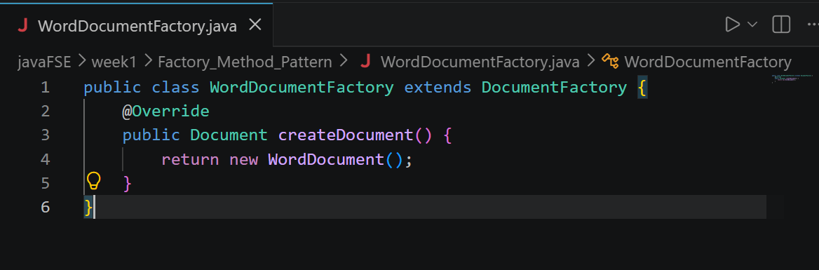
OUTPUT:
